Requirement Analysis Phase – Document IV

The Requirement Analysis Phase focuses on understanding, analyzing, and implementing how the Garage Management System (GMS) processes and presents data for operational and managerial insights. This phase ensures that all user, business, and reporting requirements are addressed within the Salesforce environment through the use of reports, dashboards, and record creation.

Objective
To analyze data flow requirements, define measurable outputs, and implement Salesforce analytical tools (Reports & Dashboards) that help monitor garage performance, customer satisfaction, and service quality.

Key Activities
1. Reports
- Purpose: Reports are used to retrieve, analyze, and visualize data from multiple Salesforce objects, helping stakeholders make informed decisions.
- Types of Reports Implemented:
  - Tabular Reports: Display simple lists of records.
  - Summary Reports: Group and summarize data.
  - Matrix Reports: Compare related totals across two dimensions.
  - Joined Reports: Combine multiple report types for comparative analysis.

a. Report Folder Creation
- Created a dedicated folder named “Garage Management Folder” to store and organize reports.
- Shared the folder with the Manager role with View access to enable controlled data visibility.

b. Custom Report Type
- Primary Object: Customer Details
- Related Objects: Appointments, Service Records, and Billing Details & Feedback
- Created a Custom Report Type named “Service Information” to connect these objects and consolidate all related data into a single report.
- Deployment Status: Deployed

c. Report Creation
- Process:
  - Selected the custom report type Service Information under the “Other Reports” category.
  - Added fields such as:
    - Customer Name
    - Appointment Date
    - Service Status
    - Payment Paid
  - Grouped by:
    - Rating for Service
    - Payment Status
  - Added a Line Chart to visualize service performance over time.
- Report Name: New Service Information Report
- Outcome: Enabled visual tracking of service progress, payment patterns, and customer ratings.
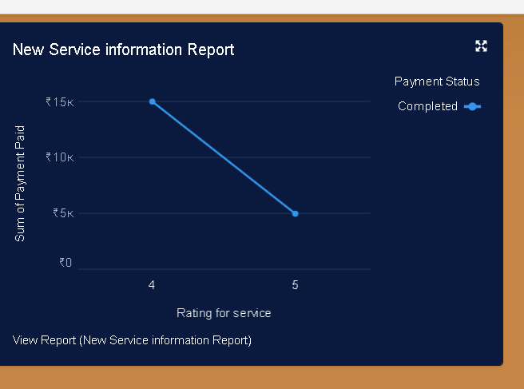

2. Dashboards
- Purpose: Dashboards provide real-time visual insights into garage operations using graphical representations of report data.
a. Dashboard Folder
- Created a folder named “Service Rating Dashboard” for storing visual analytics.
- Applied similar sharing permissions as the report folder to ensure data consistency and controlled access.
b. Dashboard Creation
- Process:
  - Created a new dashboard and linked it to the Service Information Report.
  - Selected Line Chart as the visualization type.
  - Customized chart theme for better readability.
  - Saved and configured the dashboard for automatic updates.
  - Enabled Subscription:
    - Frequency: Weekly
    - Day: Monday
- Outcome: Automated data monitoring with weekly performance summaries emailed to stakeholders.
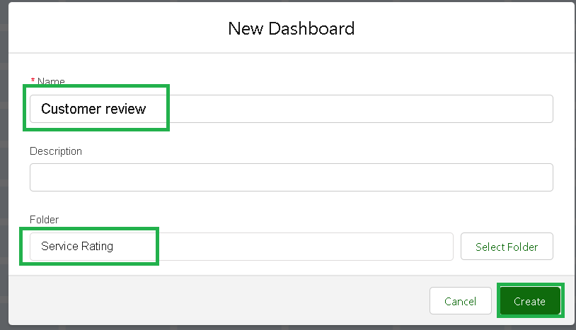

3. Record Creation and Validation Testing
- Purpose: To verify the correctness of configured fields, relationships, and automation through actual data entry.
- Process:
  - Created new records for each object (Customer Details, Appointments, Service Records, Billing & Feedback).
  - Validated:
    - Appointment dates comply with validation rules.
    - Vehicle number format matches the pattern.
    - Automatic Service Amount calculation and Service Status update upon Quality Check.
- Outcome: Confirmed proper system integration and rule execution, ensuring smooth end-to-end functionality.
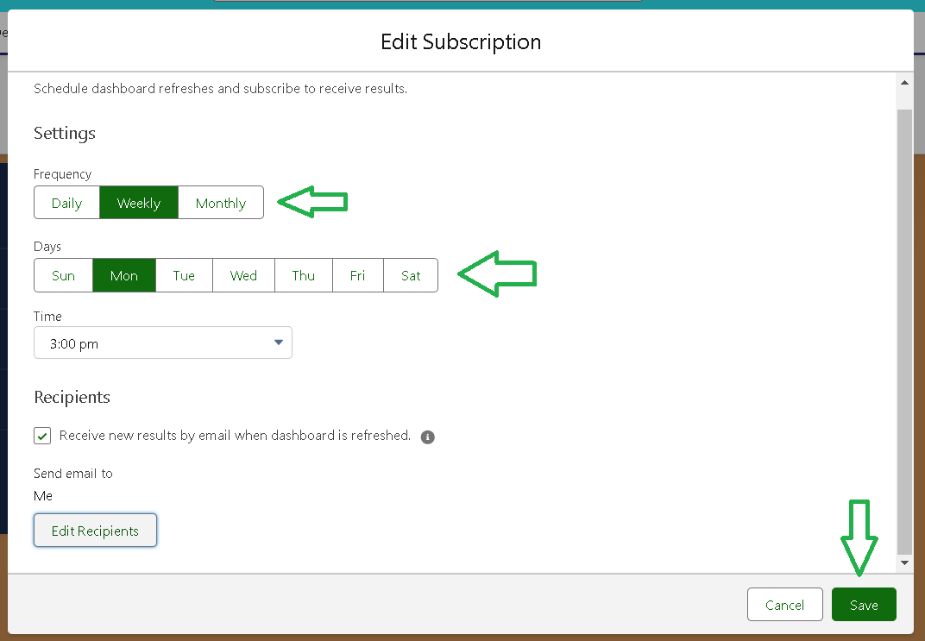
Outcomes of the Requirement Analysis Phase
By the end of the Requirement Analysis Phase, the Garage Management System achieved:
- Complete data visibility across interconnected objects via reports and dashboards.
- Functional data analysis tools for decision-making and performance monitoring.
- Validated records and workflows, confirming that automation and rules perform as expected.
- Enhanced user experience with simplified access to metrics like service completion rates, revenue tracking, and customer feedback trends.

